**2025 Heartland Hsopital Medicine Conference**

**Dermatological Emergencies in Hospital Medicine**

**Take-Home Packet**

This handout includes:

* **Table 1**: Glossary of dermatologic terminology
* **Table 2**: Recommended initial actions prior to transfer for non-burn skin failure
* **Table 3**: Triage criteria for transfer to burn centers
* **Table 4**: Examples of primary and secondary dressings: advantages and disadvantages
* **Figure 1**: Tools for estimating total body surface area (TBSA)

**Table 1.** Glossary of dermatology terms used in this paper

|  |  |
| --- | --- |
| **Terminology** | **Definition** |
| **Macule** | Flat, non-palpable lesion < 1 cm in diameter, which contrasts in color from the surrounding skin. |
| **Patch** | Flat, non-palpable lesion ≥ 1 cm in diameter. |
| **Papule** | Raised, solid, palpable lesion < 1 cm in diameter. |
| **Plaque** | Raised, palpable lesion ≥ 1cm in diameter, which may result from merging multiple papules and can exhibit various surface characteristics, such as scaling, crusting, or smoothness. |
| **Nodule** | Raised, solid, palpable lesion > 1 cm in diameter, found in skin layers including the dermis and subcutaneous tissue and extending into deeper structures. |
| **Vesicle** | Raised, fluid-filled lesion < 1 cm in diameter; may contain clear serum, blood, or pus (see pustule). |
| **Bulla** | Raised, fluid-filled lesion ≥ 1 cm in diameter; may contain clear serum, blood, or pus. |
| **Pustule** | Raised,well-defined, small pus-filled lesion < 1 cm. |
| **Scale** | Dry, flaky debris that appears white or grayish due to the buildup of keratinized cells. |
| **Crust** | Dry residue from serum, blood, or pus on the skin surface. |
| **Erosion** | Superficial, moist, and often depressed lesion due to localized loss of the epidermis without extension below the dermoepidermal junction. |
| **Excoriation** | Superficial lesion due to loss of the epidermis due to mechanical trauma. |
| **Ulcer** | Deep, full-thickness loss of the epidermis that extends into the dermis or deeper tissues. |

**Table 2.** Recommended Actions for Transferring Hospitals to Initiate When Managing Patients with Non- Burn Skin Failure Prior to Transfer to a Burn Center

|  |  |
| --- | --- |
| Categories | **Recommended Actions\*** |
| **Initial Assessment** | Perform a thorough history, physical exam, and lab tests. Discontinue any offending drugs immediately. |
| **Airway Management** | Secure airway early if needed. |
| **Fluid Resuscitation** | Administer crystalloids for IV fluid replacement. |
| **Nutritional Support** | Provide high-protein enteral nutrition or initiate tube feeds. |
| **Thermoregulation** | Maintain ambient temperature around 30°C or use external warming devices. |
| **Wound Care** | Apply moist, layered dressings to minimize trauma and infection risk. |
| *Transfer to a burn center if unable to provide these interventions. | |

Table 3. Criteria for transfer for patients with non-burn skin emergencies to a burn center

|  |  |  |
| --- | --- | --- |
|  | **Triage recommendations** | **Comments** |
| >25% BSA Detachment +/-  Airway involvement or ICU  indications | Admit to burn unit | Severe cases requiring specialized  care and monitoring |
| <25% BSA Detachment +  Airway involvement or ICU  indications | Admit to ICU with burn  consult | Includes patients with systemic complications or rapid clinical  deterioration |
| <25% BSA Detachment + No  airway involvement or ICU  indications | Admit to hospitalist service  with burn consult | Close monitoring is essential to detect and respond to any  worsening |

**Table 4. Examples of Primary and Secondary Dressings: Advantages and Disadvantages**

|  |  |  |  |
| --- | --- | --- | --- |
| **Dressing Type** | **Description** | **Advantages** | **Disadvantages** |
| **Primary dressings (apply directly to wound) \*** | | | |
| **Silver foam dressing** | e.g. Mepilex AG ® | Prolonged wear time.  Regulates moisture.  Prevents infection.  Gentle on skin. | High cost.  Small sizes.  May require additional dressings for heavily draining wounds. |
| **Conformant** | Wound veil | Non-occlusive, allowing drainage absorption.  Suitable for large surface areas | Limited availability.  Requires additional ointments to prevent adherence. |
| **Xeroform ™** | Gauze strip with 3% Bismuth Tribromophenate in petrolatum. | Eliminates need for additional ointments.  Possesses antimicrobial properties. | Limited to small surface areas.  Occlusive, necessitating frequent changes to prevent maceration. |
| **Petrolatum gauze strip** | Gauze strip infused with petrolatum jelly. | No additional ointments needed. |
| **Adaptic** ® | Gauze strip with petrolatum emulsion. | No additional ointments needed.  Non-occlusive, facilitating drainage. | Limited to small surface areas. |
| **Telfa ™** | Gauze pad with a plastic like coating to prevent adhesion. |  | Limited to small surface areas.  Requires additional ointments to maintain non-adherence. |
| **Secondary dressings (place over primary dressings)** | | | |
| **Burn Flats** | Large woven gauze, | Effective for large areas.  Highly absorbent. | Bulky.  Not widely available. |
| **Abdominal Pads** | Absorbent gauze pads. | Highly absorbent. | Small size.  Potential for incorrect application affecting absorption. |
| **Kerlix ™** | Rolled gauze | Effective for wrapping extremities and securing  other dressings (e.g. abdominal pads or burn flats). | May require multiple layers for adequate absorption. |

**\***All primary dressings need to be covered with absorbent dressings such as abdominal pads or a burn flat gauge.

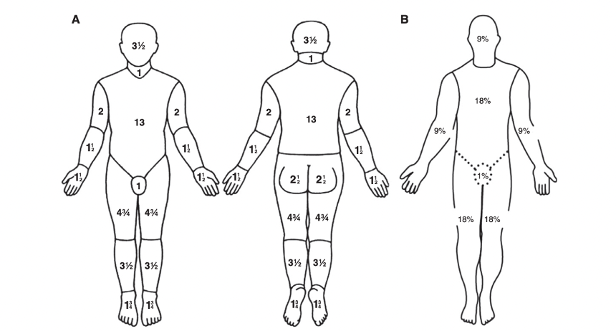

**Figure 1.** Defining TBSA. (A) The Lund-Browder diagram is a slightly more complex grading system and gives a more precise BSA. (B) The rule of “nines” is a more simplified version but is easier to remember. BSA = body surface area.